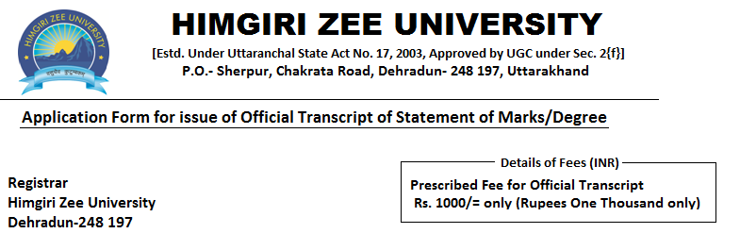
- Name of Candidate (in Block Letters): __________________________________________
- Father’s Name : __________________________________________________________
- Mother’s Name : __________________________________________________________
- Faculty/Department: ______________________________________________________
- University Enrollment No. : _______________________ Roll No.: ___________________
- Particulars of Examination Passed. (Please attach copies of all the mark sheets):

Examination | Year/  Semester | Year of Passing | Result | Marks  obtained | Division/Grade
- Mailing address:
Name :
Address:
Pin Code No.: Mail ID: Mob. No.

(Signature of Applicant)

FOR OFFICE (ACCOUNT SECTION) USE ONLY
Received a Sum of Rupees ________________________only through Cash/Bank Draft/Money transfer in account of Himgiri Zee University, Dehradun at Punjab National Bank, Yamuna Colony, Dehradun A/C No. – 3968002100013368, IFSC Code- PUNB 0396800 and entered in Receipt No. _________________
Date ___________________
Accountant

INSTRUCTIONS
- All public dealings are made from 9:30 A.M. TO 4:30 P.M.
- The Particulars of the student given in the form should correspond with those appearing in the certificate issued to him/her from time to time. The application form must be signed by student and in no case by some else on his/her behalf.

- Photocopies of all the mark sheets of the Examination taken by the candidate be enclosed with the application form.

- The required transcript will be issued after a period of seven days excluding Saturday/Sunday.

- The delivery of the Certificate will be made in person to the Candidate or to his nominee, authorized in writing, at the University Office during working hours.

- The prescribed fee is as follows:
Rs. 1000/= only (Rupees One Thousand only) per copy
Rs. 500/= only (Five Hundred only) for each additional copy

- Please note that the additional copy charges are applicable only in case the copies are requested at the time of original Transcript and not at a later stage.

Received documents,

Signature of the applicant

